**James Maddalena**

**Discography**

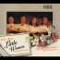

Mark Adamo: Little Women

Houston Grand Opera / Patrick Summers, conductor

Ondine ODE 988-2D



John Adams: The Death of Klinghoffer

Kent Nagano, conductor

Nonesuch 79281



John Adams: Nixon in China

Orchestra of St. Luke’s / Edo De Waart, conductor

Nonesuch 79177

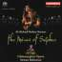

Sir Richard Rodney Bennett: The Mines of Sulphur

Glimmerglass Opera Orchestra / Stewart Robertson, conductor

Chandos CHSA 5036(2)

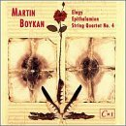

Martin Boykan: Elegy, Epithalamion, String Quartet 4

David Hoose, conductor

Composers Recordings 786

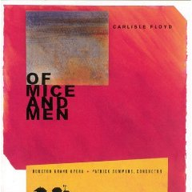

Carlisle Floyd: Of Mice and Men

Houston Grand Opera / Patrick Summers, conductor

Albany TROY 62122

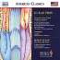

Lukas Foss: Song of Anguish, Elegy for Anne Frank, Lammdeni, Adon Olam / Robert Beaser: The Heavenly Feast

Laudibus / Gerard Schwarz, conductor

Naxos 8.559438

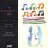

Charles Fussell: The Astronaut’s Tale

Monadnock Festival Orchestra / James Bolle, conductor

Albany TROY616

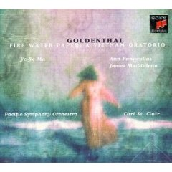Elliot Goldenthal: Fire Water Paper (A Vietnam Oratorio)

Pacific Symphony Orchestra / Carl St. Clair, conductor

Sony 68368

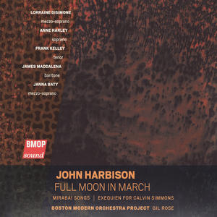

John Harbison: Full Moon in March

Boston Modern Orchestra Project / Gil Rose, conductor

BMOP/sound 1010

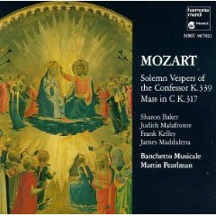

Wolfgang Amadeus Mozart: Solemn Vespers of the Confessor

Banchetto Musicale / Martin Pearlman, conductor

Harmoni Mundi Fr. 907021

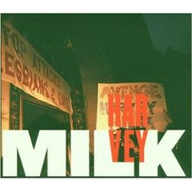

Stewart Wallace: Harvey Milk

San Francisco Opera Chorus, San Francisco Opera Orchestra

Donald Runnicles, conductor

Teldec 0630-15856-2

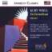

Kurt Weill: The Eternal Road

Gerard Schwarz, conductor

Naxos 8.559402

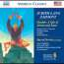

Judith Lang Zaimont: Sacred Service for the Sabbath Evening, A Tale of Abram and Isaac

Berlin Radio Symphony Orchestra / Gerard Schwarz, conductor

Naxos 8.559444

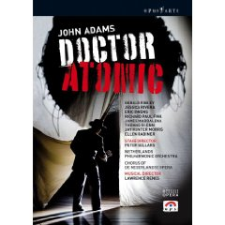**DVDs**

John Adams: Doctor Atomic

Netherlands Philharmonic Orchestra / Lawrence Renes, conductor

BBC/Opus Arte OA0998D



George Frideric Handel: Giulio Cesare

Dresden State Orchestra / Craig Smith, conductor

Decca DEC B000725309

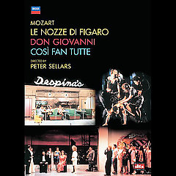Wolfgang Amadeus Mozart: The Da Ponte Operas

Arnold Schoenberg Choir, Vienna Symphony Orchestra

Craig Smith, conductor

Decca DEC B000530309