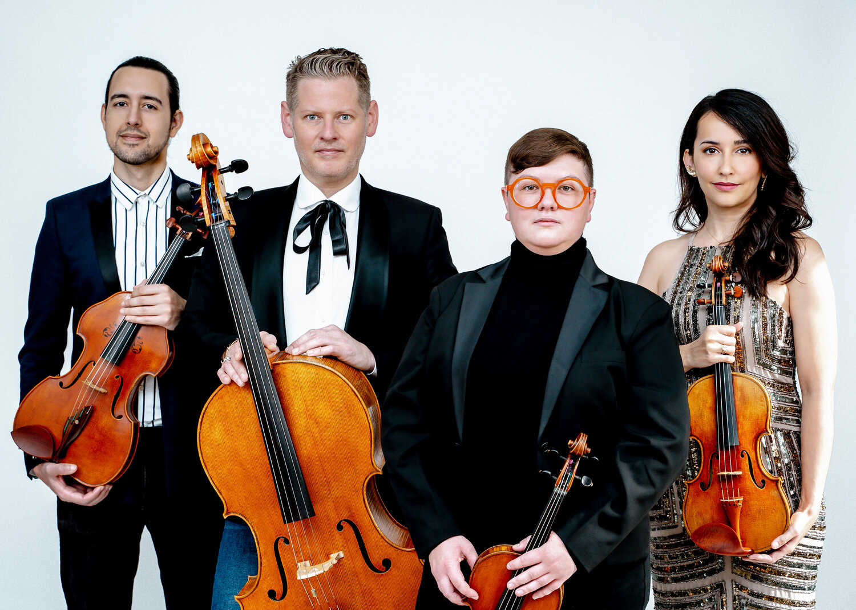

Catalyst Quartet
Karla Donehew Perez, violin Abi Fayette, violin
Paul Laraia, viola Karlos Rodriguez, cello
“Like all great chamber groups, the Catalyst Quartet is beautiful to watch, like a family in lively conversation at the dinner table: anticipating, interrupting, changing subjects.”
New York Times - August 5, 2020
Hailed by The New York Times at its Carnegie Hall debut as “invariably energetic and finely burnished… playing with earthy vigor,” the Grammy Award-winning Catalyst Quartet was founded by the Sphinx Organization in 2010. The ensemble (Karla Donehew Perez, violin; Abi Fayette, violin; Paul Laraia, viola; and Karlos Rodriguez, cello) believes in the unity that can be achieved through music and imagine their programs and projects with this in mind, redefining and reimagining the classical music experience.

Catalyst Quartet has toured widely throughout the United States and abroad, including sold-out performances at the Kennedy Center in Washington D.C., at Chicago’s Harris Theater, Miami’s New World Center, and Stern Auditorium at Carnegie Hall. The Quartet has been guest artists with the Cincinnati Symphony, New Haven Symphony, St. Paul Chamber Orchestra, and the Orquesta Filarmónica de Bogotá, and served as principal players and featured ensemble with the Sphinx Virtuosi on six national tours. They have been invited to perform by prominent music festivals ranging from
Mainly Mozart in San Diego, to the Sitka Music Festival and Juneau Jazz and Classics in Alaska, and the Grand Canyon Music Festival, where they appear annually. Catalyst Quartet was ensemble-in-residence at the Vail Dance Festival in 2016. In 2014, they opened the Festival del Sole in Napa, California performing with Joshua Bell, and as part of the Aldeburgh Music Foundation String Quartet Residency gave two performances in the Jubilee Hall in Aldeburgh, UK.

International engagements have brought them to Russia, South Korea, Mexico, Argentina, Colombia, Cuba, and Puerto Rico, along with regular concert tours throughout the United States and Canada. Residents of New York City, the ensemble has performed at the Metropolitan Museum of Art where they were named Quartet in Residence for the MetLiveArts 2022-23 Season, City Center, Columbia University’s Miller Theatre, The New School (for Schneider Concerts), and Lincoln Center. They played six concerts with jazz vocalist Cécile McLorin Salvant for Jazz at Lincoln Center. The subsequent recording won the 2018 Grammy Award for Best Jazz Vocal Album.

Recent programs and collaborations have included Encuentros, with cellist Gabriel Cabezas; (im)igration, with the Imani Winds; and CQ Minute, 11 miniature string quartets commissioned for the quartet’s 10th anniversary, including works by Billy Childs, Paquito D’Rivera, Jessie Montgomery, Kevin Puts, Caroline Shaw, and Joan Tower. UNCOVERED, a multi-CD project for Azica Records celebrates important works by composers sidelined because of their race or gender. Volume 1 with clarinetist Anthony McGill and pianist Stewart Goodyear, includes music of Samuel Coleridge-Taylor. Volume 2 with pianist Michelle Cann features music of Florence Price; it was nominated for “Recording of the Year 2022” by Limelight Magazine, Australia. Volume 3 will be released in 2023. Uncovered is also the focus of live concerts performed throughout the US including a four-concert Uncovered series with San Francisco Performances in 2021-22 and an upcoming Uncovered festival there in 2023.

Catalyst Quartet’s other recordings span the ensemble’s scope of interests and artistry. The Bach/Gould Project pairs the Quartet’s arrangement of J.S. Bach’s Goldberg Variations with Glenn Gould’s String Quartet Op. 1. Strum is the debut album of composer Jessie Montgomery, former Catalyst Quartet violinist. Bandaneon y cuerdas features tango-inspired music for string quartet and bandoneon by JP Jofre, and Dreams and Daggers is their GRAMMY-winning album with Cecile McLorin Salvant.

Catalyst Quartet combines a serious commitment to diversity and education with a passion for contemporary works. The ensemble serves as principal faculty at the Sphinx Performance Academy at the Juilliard School, the Cleveland Institute of Music, and Curtis Institute of Music. Catalyst Quartet’s ongoing residencies include interactive performance presentations and workshops with Native American student composers at the Grand Canyon Music Festival and the Sphinx Organization’s Overture program, which delivers access to music education in Detroit and Flint, Michigan. Past residencies have included concerts and masterclasses at the University of Michigan, University of Washington, Rice University, Houston’s Society for the Performing Arts, Cincinnati College-Conservatory of Music, The Virginia Arts Festival. Pennsylvania State University, the In Harmony Project in England, University of South Africa, and The Teatro De Bellas Artes in Cali, Colombia. The ensemble’s residency in Havana, Cuba for the Cuban American Youth Orchestra in January 2019, was the first by an American string quartet since the revolution.
Catalyst Quartet members hold degrees from The Cleveland Institute of Music, The Juilliard School, The Curtis Institute of Music, and New England Conservatory. Catalyst Quartet is a Sphinx ensemble and proudly endorses Pirastro strings. Learn more at www.catalystquartet.com.

August 2022 - please discard any previous versions.

Members of the Catalyst Quartet
Karla Donehew Perez, violin
A founding member of the Catalyst Quartet, Karla Donehew Perez maintains a busy performance schedule throughout the United States and around the world. In addition to her work with the Catalyst Quartet, she has been a featured soloist with the Berkeley Symphony, Sacramento Philharmonic, San Francisco Chamber Orchestra, Oakland East Bay Symphony, Puerto Rico Symphony Orchestra, Sphinx Symphony Orchestra, Sphinx Chamber Orchestra, and the New World Symphony. She has performed with Orpheus Chamber Orchestra and collaborated with Joshua Bell, Zuill Bailey, Awadagin Pratt, Anthony McGill, Stewart Goodyear, Fredericka Von Stade, Garry Karr, and members of the Guarneri, Juilliard, and Takács quartets. Donehew Perez has been guest concertmaster at the Tucson Symphony and spent two years as a fellow at the New World Symphony, often as concertmaster or principal second violin.
Born in Puerto Rico, Donehew Perez began playing the violin at age three. She made her solo debut with the Puerto Rico Symphony when she was nine. After moving to California she studied with Anne Crowden of The Crowden School. She holds bachelor and master degrees from the Cleveland Institute of Music where she studied with Paul Kantor, David Cerone and William Preucil. She is on the faculty of the Longy School of Music at Bard College.

Donehew Perez performs on a violin made in 2013 by renowned German luthier Stefan Peter Grenier, supported in part by a Sphinx MPower Artist Grant, and a violin bow by Victor Fetique on loan from the Rachel Elizabeth Barton Foundation.

Abi Fayette, violin
Violinist Abi Fayette’s performances have taken her all over the world, spanning the United States, Europe and Asia. She is a member of the Orpheus Chamber Orchestra. As a chamber musician she has performed with Jonathan Biss, Brett Dean, Gary Hoffman, Kim Kashkashian, Ida Kavafian, Joseph Silverstein, Steven Tenenbom, Jörg Widmann and Peter Wiley. She has performed at Kneisel Hall, Music from Angel Fire, The Taos School of Music, and the Marlboro Music Festival. She began appearing with the Catalyst Quartet during the 2019-20 season.
Raised in a musical family, her violin studies began at age three. She was enrolled in the Juilliard School’s Pre-College Division and studied with Shirley Givens, Ann Setzer, Kyung-Wha Chung, and Joseph Silverstein. She holds a bachelor degree from The Curtis Institute of Music and a masters degree from the New England Conservatory. During the 2019-20 season Fayette was a Community Artist fellow at the Curtis Institute of Music working in the Philadelphia School District on music education programs.

Abi performs on a violin made in 1860 by Jean-Baptiste Vuillaume, generously on loan from Marlboro Music.

Paul Laraia, viola
Praised by The Strad for "eloquent” and "vibrant" playing, violist Paul Laraia enjoys a multifaceted career as soloist, chamber musician and advocate for new music. He has appeared as soloist with the Pittsburgh Symphony, Atlanta Symphony, New Jersey Symphony, Nashville Symphony, St. Paul Chamber Orchestra and Filharmonica De Bogata, at festivals including the Yellow Barn, Sarasota, Vail International Dance, Festival Del Sole, Incheon Music Hic Et Nunc!, Hong Kong Generation Next Arts, Sitka, Banff, Grand Canyon, and Cornell’s Mayfest. He has performed chamber music with Gil Shaham, Joshua Bell, Yo Yo Ma, Jorg Widmann, Vadim Repin, Edgar Meyer, Donald Weilerstein, Cho-Liang Lin, Roger Tapping, Anthony Marwood, Daniel Phillips and Paul Huang. Laraia recently recorded a solo debut album of Bach, Reger, Hindemith and Henze for the White Pine label.

The New Jersey native first studied viola with Brynina Socolofsk, and later with Kim Kashkashian at the New England Conservatory of Music. He was First Prize Winner of the 2011 Sphinx Competition and in 2019, won First Prize in the Lionel Tertis International Viola Competition under whose auspices he made his recital debut at Wigmore Hall in London in 2020.

Paul Laraia performs on a Hiroshi Iizuka viola in the ‘viola d’amore’ style, and a Belgian bow by Pierre Guillaume awarded by the Bishops Strings Shop in London.
Karlos Rodriguez, cello
A founding member of the Catalyst Quartet, Cuban-American cellist Karlos Rodriguez is a soloist, recitalist, chamber musician, clinician, recording artist, writer and administrator.

The winner of competitions and prizes, he has appeared at Carnegie Hall, David Geffen Hall and Alice Tully Hall at Lincoln Center, The Kennedy Center for the Performing Arts, The New World Center and Philadelphia’s Kimmel Center. Rodriguez has also been honored to work with numerous distinguished artists such as the Beaux Arts Trio, the American, Cavani, Cleveland, Emerson, Guarneri, Juilliard, Miami, Orion, Tokyo and Vermeer String Quartets; Janos Starker, Lynn Harrell, Zuill Bailey, Pieter Wispelway, Rachel Barton-Pine, Awadagin Pratt, Joshua Bell, Anthony McGill, Paul Neubauer, and Steven Isserlis.

A love of dance led to collaborations with the Thomas/Ortiz Dance Company, Freefall, Mark Morris Dance Group, Vail International Dance Festival, and Chita Rivera. Rodriguez has attended and been a guest artist at the Encore School for Strings; the Sarasota, Strings, Aspen, Grand Canyon, Great Lakes and Kneisel Hall chamber music festivals; the Cleveland Chamber Music Society, Philadelphia Orchestra Chamber Music Society, and Napa’s Festival Del Sole. As an educator, he is the Director of Artistic Affairs for the Sphinx Performance Academy at the Cleveland Institute of Music, Curtis Institute of Music and the Juilliard School, and has given master classes domestically and abroad.

Rodriguez has worked on commercials and films, collaborated with pop artists such as Shakira, John Legend, Pink Martini, and contributed to numerous Broadway musicals. He is a member of the Radio City Music Hall Orchestra and past principal cellist of the Florida Grand Opera Orchestra. Rodriguez is also the author of Living and Sustaining a Creative Life-Music, published by Intellect Books UK. His teachers have included Richard Aaron, Peter Wiley and David Soyer.

Karlos Rodriguez plays on a cello by award-winning luthier Michael Doran made possible through a Sphinx MPower Artist Grant

Catalyst Quartet in Concert:
After the hiatus, live classical music in 2021 was bursting with treasure
“Catalyst Quartet: It’s past time to restore the work of overlooked Black composers to its proper place in concert life. The superb November 11 recital presented by San Francisco Performances - second in the four-program series Uncovered that extends into 2022 - made this point unequivocally, through skillful renditions of pieces by Florence Price, Coleridge-Taylor Perkinson and Samuel Coleridge-Taylor, all of which can easily claim a spot alongside the more traditional fare of the chamber music world.” San Francisco Chronicle - December 22, 2021

Catalyst Quartet’s program lands as a revelation
“There’s been a lot of talk recently about expanding repertoire for chamber music to include the contributions by composers of color. It could look something like the terrific recital given by the Catalyst Quartet: an evening of smart, arresting music by Black composers, executed with skill and panache. As part of its ‘Uncovered’ project the ensemble performed a range of music that rarely, if ever, shows up on chamber programs. Coleridge-Taylor Perkinson’s warm, evocative String Quartet gave way to ‘Five Folksongs in Counterpoint’ by Florence Price. Clarinetist Anthony McGill joined the group for a luminous account of Samuel Coleridge-Taylor’s Clarinet Quintet. The notion that the classical tradition has identified all the chamber music worth hearing isn’t simply wrong, it’s laughable. You could go to chamber concerts for years and never hear a program as full of surprises and discovery as this one. We’ve been missing out. Certainly we haven’t heard anything quite like Perkinson’s beautiful work, which synthesizes lush, tangy jazz harmonies with a gestural language out of Beethoven. The buoyant melodic theme was still echoing in my memory hours after the performance. Price’s work is a small masterpiece of wit and invention. Coleridge-Taylor’s Quintet unfolded on stage in great waves of ingratiating melody and brisk harmonic surprises. It’s a vibrant score that deserves wider currency. The quartet performed all of this music with the clarity and vigor of a great ensemble. If the spotlight hadn’t been modestly turned toward the composers, a listener might have marveled more consciously at the group’s artistry, but it was in evidence throughout.”
San Francisco Chronicle – November 12, 2021
“For its welcome return engagement to the Maverick, the Catalyst Quartet began with the string quartet hit, Strum by Jessie Montgomery. This attractive, imaginative, and ingratiating little piece seems as though it is destined for the dance. Sorrow Song and Jubilee by Libby Larsen is a fantasia on ‘Swing Low, Sweet Chariot,’ full of inventive touches and attractive ideas about what a string quartet can sound like. It scored a hit with the audience, and with this listener. The first half concluded with Five Folksongs in Counterpoint by Florence Price who has been attracting a lot of attention. Cheers and yells greeted its conclusion. Involved and vital playing earned much of the approval The Catalyst Quartet joined Gortler for Dvořák’s great Quintet. I it was easy to hear, and see, that they were having great fun. It’s treasurable when contemporary performers can bring back the19th century in style. The Maverick audience obviously felt the same way, as the performance garnered the same cheers heard after the Price.”
Boston Musical Intelligencer - August 28, 2021
“Friday’s concert came with another reminder of humanity: a live audience, both online as well as 25 distanced listeners in the hall. The sound of applause is oddly reassuring at a time like this. It must give the performers a reason to be on their mettle, which the Harlem and Catalyst Quartets clearly were.”
Philadelphia Inquirer – October 31, 2020
“Like all great chamber groups, the Catalyst Quartet is beautiful to watch, like a family in lively conversation at the dinner table: anticipating, interrupting, changing subjects.”
New York Times - August 5, 2020
“Classical music filled Schwab Auditorium as Imani Winds and Catalyst Quartet performed while celebrating and reflecting on immigration in the United States. The piece featured five movements, with four spirituals and one song based on McCauley’s work on railroads and building the Panama Canal. What an honor it is to be in the audience when a new piece is born.”
The Collegian – September 29, 2019

“With the Catalyst Quartet, “Banner” essentially breaks its source material to fix it, making musical space for the bodies and lives that have made America what it is today. As they swept into the piece, members of the quartet took the audience somewhere far beyond, sailing through music history note by note. Strains of the nineteenth-century original bend and crack, releasing a world of possibilities; a tinny not-quite-waltz crashed right into folk and bluegrass, frenzied strings falling to a hush. Drums rolled. Feet stomped. A march, deconstructed, rippled across the stage. As it coasted over the hall, the piece became deeply timely, a statement that no one needs to make America great again. Its immigrants, its composers, its union workers and astronauts and freedom fighters and city slickers and soybean farmers make it great in one soupy, glorious cacophony. That the country’s history is baked into its music, and audiences might as well start listening.”
TheArtsPaper – September 27, 2019
“The Catalyst Quartet, an excellent contemporary-focused foursome, made its Maverick Concerts debut with adept performances of a wide variety of music, beginning with an arrangement of Bach’s Goldberg Variations. It set forth Bach’s music in a reasonable way, clear, well-balanced, with individual voices sometimes taking on more prominence than possible on the harpsichord. This is music on a monumental scale: should last as long as a Mahler Symphony. So the Catalyst Quartet’s Goldbergs provided just a hint what Bach intended, but I’d stand in line for tickets to hear the group play it in full. No doubt some readers of this review enjoy Philip Glass’s music. His String Quartet No. 3 is made up of music he wrote for the film Mishima. The audience responded to the energetic performance with wild cheering. Pianist Daniel Gortler joined the Catalyst Quartet for a super-sexy performance of Franck’s Piano Quintet, one of the greatest examples of musical erotica. I hear the conclusion of the first movement as a graphic musical orgasm, and that’s the way they rendered it, as part of a lush and free interpretation with plenty of the fire Franck requested in the finale. In 90-degree heat, relieved only somewhat by Maverick’s wonderful Big Ass Fans (that’s what they’re really called), the Catalyst Quartet really steamed up the joint.”
Hudson Vallejo One – August 1, 2019

“When the Catalyst Quartet appeared at Sunset Center, we heard four fabulous musicians and a fabulous program — by any standard, a great combination. Every once in a while, we hear a concert in which the polish and refinement of the musicians’ individual mastery combined with their ability to respond to each others individual artistic skills produces a concert in which there is an inevitability about the playing. Simply said, it was difficult to imagine the works they performed being played any other way. I witnessed something I had never observed before: violinist Karla Donehew Perez played first chair in the first half of the concert, and Jessie Montgomery, in the second half. Bravo! We are now adding artistic equality to gender equality. The most impressive work on the program was Ginastera’s String Quartet No. 2. It received a totally compelling performance. It contained drama, virtuosity, sensitive soul tugging sentiment and powerful dancelike elements. Right from the opening moments we were swept up in a violent, energetic world that kept us riveted throughout five movements. Dynamics were very impressive: lots of fire and fury, but in the quietest moments, we heard many shades of pianissimo that always had substance and shape. Perez produced some astonishingly pure harmonics that were dazzling. Also tremendously effective were Piazzolla’s Suite del Angel and Heitor Villa-Lobos’ String Quartet No. 1. We heard quartet playing at its very best. Responding to tumultuous applause, the Catalyst Quartet gave us one encore. This performance brought tears to my eyes and a lump to my throat.”
Peninsula Reviews - February 24, 2019
“Who would have suspected an entire program of regional premieres? The Catalyst’s ‘tour of South America’ accounted for an entertaining discovery of unfamiliar music including, an out-and-out masterpiece, Ginastera’s Second String Quartet. The players took special delight is exploiting a boatload of sonic techniques, some called for by the music and for sheer sport: a shocking, thrilling palette of effects all justified in artistically expressive terms. The central Presto magico sizzled like the mini-fireworks of a July 4th sparkler. The impact was as equally explosive as amusing. The Catalyst four answered the call for an encore with the haunting Aria from Villa-Lobos.”
Performing Arts Monterey Bay - February 25, 2019
“The difference between the Minnesota Orchestra and the St. Paul Chamber Orchestra? No better demonstration than how each opened its 2017-18 season. The Minnesota Orchestra brought the crowd to its feet for a traditional Star-Spangled Banner. The St. Paul Chamber Orchestra performed a kind of abstract collage of a ‘Star-Spangled Banner,’ firmly on the side of being adventurous and experimental. One offered stability while the other challenged its audience with something new and potentially controversial. Perhaps it says something about SPCO audiences that they gave composer Jessie Montgomery’s ‘Banner’ a rousing ovation. Montgomery was among the performers for ‘Banner,’ a piece for string quartet and chamber orchestra: first violinist for guest ensemble, the Catalyst Quartet. Opening the season with this work seemed to throw the gauntlet down and declare that the SPCO is all about adventure and unpredictability. I’ve liked everything I’ve heard of Montgomery’s, and this was no exception, thanks in great part to the passionate performance of both the Catalyst Quartet and the SPCO.” St. Paul Pioneer Press - September 15, 2017
“There is a moment in Montgomery’s Banner when the energetic motion of its start comes to a halt, dissolves in a series of sliding harmonics, hand drumming on the upright bass, and lightly bowed fragments in alternation. The quartet takes over, and the whole ensemble strikes a heartbeat on the floor with their feet. This leads us on a tour of music from countries and territories surrounding the United States. In its finale, the heartbeat becomes a flutter – and, as the man next to me said, ‘Wow,’ the piece was over. As an introduction to Montgomery’s work and the Catalyst Quartet, it certainly makes one wish that the program had been a little longer with more of them in it.” Twin Cities Arts Reader - September 19, 2017
Puerto Rican debut for Pro Arte Musicale at Sala Pablos Casals:
“It was surprising to hear the caliber of sound quality of the Catalyst’s reading of the first Villa-Lobos for this production. The suggestive titles corresponded with a delicious interpretation by the guest artists. From the subtle elegance of the ‘Cantilena,’ to a highlight with violist Paul Laraia in the third movement; the fine musicality and perfect intonation of the ‘Cançoneta;’ the expressive melody in the hands of Cuban cellist Karlos Rodriguez for the ‘Melancolia;’ to the conclusion with synchronized breathing of exquisite taste and overwhelming force in ‘Saltando como um Saci.’ They closed the program with exceptional brilliance in their own arrangement of Piazzolla’s ‘Suite del Ángel’.” El Nuevo Dia –-April 4, 2017
“Catalyst Quartet was in stunning form, with elegiac sound, and great flexibility due to listening intently to each other. The energy was almost unbearable, in a good way! The sum total of all Sphinx Organization activities is much more important than any one concert given: may their efforts not only thrive but increase." New York Times, October 11, 2016

Premiere of Puhutawi at the Grand Canyon Music Festival:
“A new brand of music is floating across the airwaves of northern Arizona and it sounds good. The new genre fuses traditional Hopi music with contemporary classical. A five-year endeavor birthed the concert-length composition Puhutawi, which pays homage to the Grand Canyon and helps kick-off celebrations for the 100th anniversary of the National Park Service. Hopi composer Trevor Reed wrote with the east coast string quartets Catalyst and Ethel in mind: musicians who were not necessarily Native but who were interested in getting outside the box. Puhutawi goes deeper than just blending cultures and ideas. It's about the sound itself. Tenakhongva and The Catalyst Quartet performed.” Navajo-Hopi Observer - September 6, 2016

Catalyst Quartet Gets Down and Dirty at Kohl Mansion
“Catalyst Quartet members passed for country fiddlers and even a Brazilian samba band in a recital of folk-based string quartet works. The most compelling pieces were contemporary takes on non-Western folk traditions. Stirred by his encounters with violence during a trip to Israel, Argentine composer Osvaldo Golijov drew on Middle Eastern musical traditions for Tenebrae. In one particularly chilling passage, violist Paul Laraia emulated a traditional lament, while first violinist Karla Donehew Perez provided an echo effect at the end of each phrase, playing an obsessive melodic figure as she shifted her bowing from the bridge upward toward the fingerboard. The resulting, eerie tone color sounded like it had been produced in an electronic studio rather than by an acoustic violin.” SF Classical Voice – November 18, 2015

“The Catalyst Quartet offered a dynamic performance of Joan Tower’s lyrical, melancholic ‘In Memory,’ inspired by events of Sept. 11, 2011.”
New York Times Oct. 16, 2015

“The Catalyst takes a rather old-school approach to its music-making, phrasing without excessive edginess, producing a generally mellow sonority with a big, rich bass, reminiscent of great quartets of the past such as the Guarneri and Budapest. Bartók Quartet No. 3 is a showcase of spiky harmonic language that characterizes the master’s mature music. The performance didn’t underplay those qualities – cellist Rodriguez slid quite effectively, and violinist Donehew Perez produced rarified, spider-webby figures faultlessly. The ensemble gave a comparably romantic sheen to Beethoven. String tone was robust and rounded with no shortage of vibrato, tempos were moderately paced, in the finale a hint of Haydnesque effervescence and volatility. The group’s sound and the music’s style were best reconciled in Brahms, a songful outpouring of high-romantic tone and phrasing that the four musicians audibly relished. The first violin paced a sweetly lyrical andante, and the closing movement’s set of variations found the ensemble in its most plushly sonorous collective voice.” Richmond Times-Dispatch - Sept. 9, 2015

“Classical music is for everyone – or, at least, it should be. That’s the message the Catalyst Quartet is bringing to Houston.” Houston Chronicle, TX

Northwest Bach Festival in Spokane WA:
“The Catalyst Quartet playing was a continual source of pleasure. Careful to keep within the bounds of string playing appropriate to 18th-century music, they nonetheless succeeded in revealing the wealth of wit and pathos that lies in nearly every measure of Bach’s great work. All four players employed light pressure on the string and used vibrato as Bach would have expected: as an occasional ornament, rather than a constant means of tone production. The result was a sweet, airy sound, capable of many shades of expression. In the Gould String Quartet, the group’s sound darkened considerably, in keeping with the stylistic language of the work. Early in his career, Gould was deeply involved in the music of the Second Viennese School of composers. These are the influences most noticeable in his String Quartet, and account for its dominant tone of brooding, super-heated emotion. Catalyst responded by digging into their strings more deeply and producing tone colors that would have been out of place in the Bach.” Spokesman Review - March 4, 2015

“Catalyst Quartet was excellent in Marcus Goddard’s atmospheric ‘Allaqi’ for string quartet.” New York Times - October 30, 2014
“Goddard’s Allaqi, performed by the Catalyst Quartet stood out. I was moved and enthralled by the quartet’s performance, seeing the notes lifted high into the room, painting this grand picture.” - Splash Magazine
“Catalyst Quartet played up a storm last night for Chamber Music Monterey Bay. What a way to begin a concert! Strum, written by violinist Jessie Montgomery, developed an infectious energy as it mixed rhythmic vitality with passionate lyricism. You didn’t want to end. Tenebrae, by Golijov, has a spiritual kinship to the Adagio later in the program. Especially impressive was the gorgeous playing by cellist Rodriguez against the ostinato provided by the other players. We heard beautiful and effective playing from all the Catalyst players. The concert ended with the remarkable Brahms String Quartet No. 1 in C Minor. The energy and drama, plus its supremely effective writing for the instruments, was totally absorbing. We loved it.”
Peninsula Reviews
“The Haydn war horse (Quartet in G Major, op. 76/1) got a fresh take from these youngsters. Their energy shone in the perfect ensemble unity. An unequaled class of execution continued through the entire Brahms Quartet, op. 51/1. The concluding movement was nothing short of fantastic. A cheering, standing house echoed their appreciation.”
Lincoln Journal Star
‘Strum’ by Jesse Montgomery is a great opener. The performers’ rhythmic energy, polyphonic clarity and tight ensemble–playing continued throughout the evening. Golijov’s ‘Tenebrae’ gave us a beautifully wrought, lucid and committed performance of this most moving composition. Each player shone, both as collaborators in a like-thinking ensemble and as lyric “soloists.” I was awed by their performance of Ginastera’s fiendishly difficult String Quartet No.2! This work makes incredible technical demands, and the Catalyst players were up to all of them, including a perfect sense of ensemble during the unison passages and complex first movement rhythms. The mysterious sounds were flawlessly produced. The concert was brought to a thrilling conclusion by the wild final movement, aptly marked furioso. We were treated to a delightful encore, the quartet’s arrangement of ‘El Coqui’. The Musica da Camera audience left smiling.”
New York Concert Review

“Invariably energetic and finely burnished…The Catalyst Quartet played the Allegro Rustico movement from Ginastera’s Quartet No. 2 with an earthy vigor. Osvaldo Golijov’s “Tenebrae” was given an introspective reading. Ms. Montgomery switched violins for the performance of her lively “Strum,” which featured insistent plucked rhythms and elegiac melodies. She also composed the encore, “Star-burst.” The New York Times

“Catalyst Quartet took the stage for Osvaldo Golijov’s ‘Tenebrae’, a meditative work whose floating mists and cosmic ambiguities can, in the wrong hands, seem like music to do yoga by, but the Catalyst players turned in a serious, convincing account. The tone shifted from dark to light when the quartet launched into ‘Strum,’ a hugely enjoyable work by Jessie Montgomery. Turbulent, wildly colorful and exploding with life, ‘Strum’ sounded like a handful of American folk melodies tossed into a strong wind, cascading and tumbling joyfully around one another.”
Washington Post

“Some complain that classical music was written by dead white guys, is performed by white musicians and listened to by white senior citizens. Luckily, there are groups like the Catalyst Quartet to combat this trend. Jessie Montgomery’s ‘Strum’ quickly brought back the fun energy. Under her sure guidance, melodies emerged from between the cracks of tightly nested repeating cells and snaked in and out of the pulsing framework, occasionally taking wayward dips before retreating to allow a new theme to materialize.” Oberlin Review

“The Great Lakes Chamber Music Festival draws a tight frame around a resident composer. Some of America's most celebrated have held the title. This year's composer, Joel Hoffman, feted with a concert of his works, featured compelling music, polished craftsmanship and percolating ideas that deserve wider circulation. Played energetically by the Catalyst Quartet, the String Quartet No. 4 (2011) packed a lot into three short, tightly argued movements. The music soared in the sweetly nostalgic finale.” Detroit Free Press

“Alberto Ginastera’s String Quartet No. 2 dominated the Stanford University proceedings, played by the Catalyst Quartet, first-chair players of the Sphinx Virtuosi. Scheduled to play just Ginastera's finale, in a spirit of enthusiasm they presented the whole quartet, all five movements. There was no question of the violins resting on the lower strings' laurels, with the violins giving off tight energy and surehandedness. Through Ginastera's perpetual motion opening movement and finale, his ghostly scherzo full of special sound effects, and the two cautious, softly dissonant slow movements, the resemblance to a really good performance of a Bartók quartet was unmistakable.” -
San Francisco Classical Voice

“The Catalyst Quartet performed two numbers. Michael Nyman’s String Quartet No. 2 (1988) combines elements of minimalism with a rock aesthetic in a virtuoso setting. The finale Furioso movement, from Argentinean Alberto Ginastera’s String Quartet No. 2, Op. 26 (1958), certainly shows Bartók's influence, but through a South American prism. This music is ‘in your face’ seething, frantic and fabulous fun.” Classical Voice of North Carolina

Catalyst Quartet on CD:
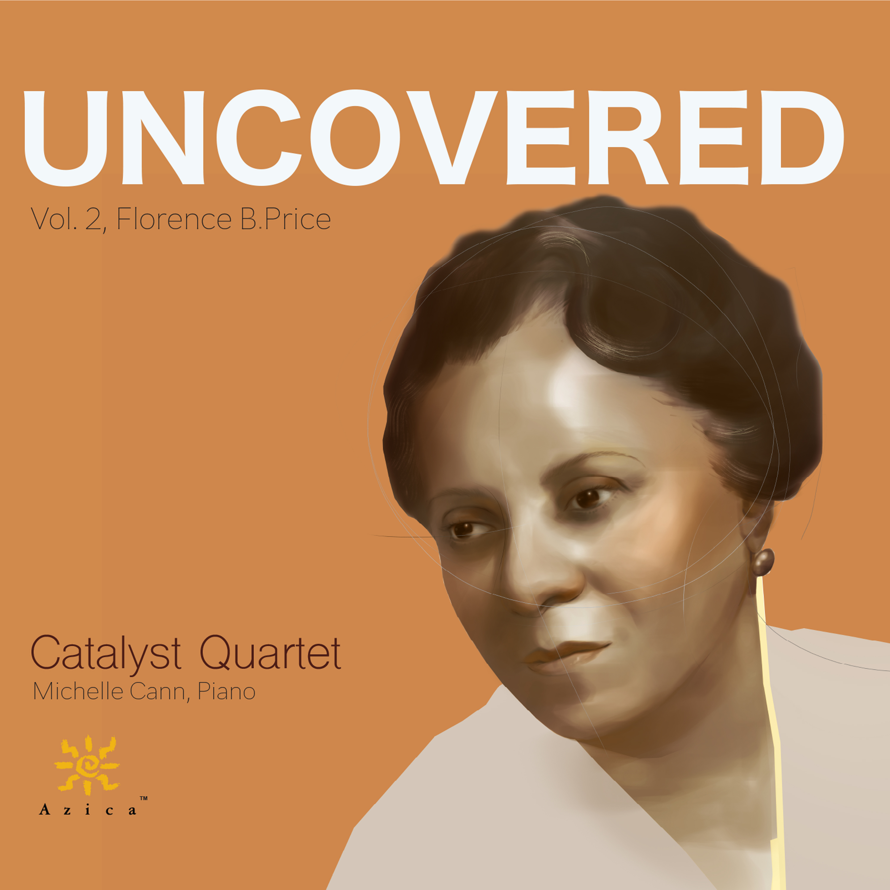
Uncovered, Vol 2 with Michelle Cann
“I can’t say enough good things about these gems. Each one is a delight.
Presenting these works are the gifted members of the Catalyst Quartet, with
pianist Michelle Cann. Cann’s piano blends and intertwines familiarly with
the Quartet players as though they played this music together every day,
adding an element of percussive energy and lyrical charm. Many thanks to the
Catalyst Quartet and all the tireless advocates who have restored the place of
Florence Price in music history for current and future generations.” Concertonet.com – July 8, 2022
“The Catalyst Quartet began its series ‘Uncovered’ with an absorbing program of Samuel Coleridge-Taylor. Price is the subject of the second volume. These scores show the composer to be a master of her craft who imbues everything with an abundance of feeling and energy, shaping forceful, poignant and inventive narratives. As on the Coleridge-Taylor album, the Catalyst Quartet play Price’s music with superb thrust and nuance.”
Gramophone Magazine – March 2022
“I’m late for Black History Month, but in the middle of International Women’s Month. Both of these groups are woefully underrepresented in the arts, hence the need to put more energy and funding into the promotion such as we see in this fine release. This is the second volume by the enterprising Catalyst Quartet‘s project to record chamber music by black composers. It is very important that recognition be given to this very fine effort rescuing important American art from oblivion. The recording starts out mightily with the Brahmsian Piano Quintet in A minor. IThis is a major work which can hold its own with works by Brahms, Schumann, Dvorak, etc.”
BBC Music – March 13, 2022

“This outstanding new release is part of Catalyst Quartet’s Uncovered Project. This second volume shines the spotlight on the chamber music of Florence B. Price. The Piano Quintets in A Minor and G Major which bookend this recital hint at darker emotional undercurrents while often bubbling over with the sheer joy of invention; the Negro Folksongs in Counterpoint and Five Folksongs in Counterpoint, both for string quartet, are radical in their sophisticated reimagining of the traditional material. And the performances? As passionate, as committed and as technically brilliant as the music itself.” Limelight Magazine - March 8, 2022

“The Catalyst Quartet's "Uncovered" series has quickly become one of the most worthwhile recording projects around, notable not just for the serious attention that the quartet is paying to Black composers who deserve it, but also for the excellence of their playing. Samuel Coleridge-Taylor was the focus of the first release; Florence Price, of the second, which offers six works, four of them premiere recordings. ‘Five Folksongs in Counterpoint,’ starts off having something of Haydn's ‘Emperor’ Quartet to it,but ends with an energy and conviction all Price's own.”
New York Times – February 24, 2022

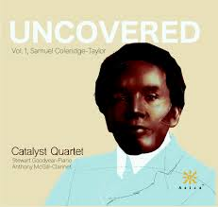
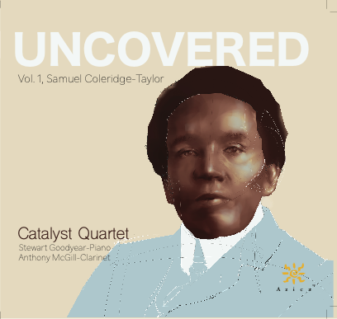
An album that’s at once musically significant but, more than that, thoroughly enjoyable.
“The Catalyst’s performance is captivating. Indeed, it takes a special kind of ensemble to pull off a piece of such contrapuntal density and technical difficulty and make it sound like they’ve been playing it forever. Suffice it to say that for security, balance, and character, the Catalyst’s take on the Price Quartet sounds as comfortable and familiar as if it were Beethoven or Brahms. The Catalyst’s performance of the set is top-drawer. The group draws out the harmonic pungency of ‘Calvary,’ gamely highlights the textural contrasts of ‘Oh my darlin’, Clementine’s’ variations, and mines the warmth and vigor, respectively, of ‘Drink to me only with thine eyes’ and ‘Shortnin’ bread.’ Most touching is the concluding ‘Swing low, sweet chariot,’ which unfolds almost like an instrumental conversation with the song’s lyrics: the questioning end of each phrase going off into a commentary or mediation on fragments of the familiar refrain. Taken together this is an album that’s at once musically significant but, more than that, thoroughly enjoyable.”
The Arts Fuse – February 23, 2022
Catalys Quartet’s richly imagined performances
“This new recording, marks another important step forwards. Here are all six of Price’s surviving works for string quartet and piano quintet in richly imagined performances by the quartet and pianist Michelle Cann. There is some heartfelt music to discover here, not least the highly romantic, large-scale String Quartet in A Minor, which is the equal of many of its time. Even the youthful, unfinished String Quartet in G Major is an innocently lyrical delight.”
Financial Times – February 11, 2022
|Uncovered, Vol. 1 with Stewart Goodyear and Anthony McGill
“The first volume focuses on Samuel Coleridge-Taylor, spanning three
beautifully performed, remarkable pieces. The Quintet for piano and strings
occupies the higher end of the emotional spectrum: adventurous, brooding,
triumphant, and psychological. The musicians tap into it all with verve, not to
mention with sterling technique and intonation. Five Fantasiestücke present a
perfect contrast. They cast a spotlight more clearly on violinists Donehew
Perez and Montgomery, violist Laraia, and cellist Rodriguez, particularly their
emotional and rhythmic interconnectedness. Their awareness of each other’s moving voices is lovely to behold in the ‘Prelude’ and quite virtuosic in the intricately interlocking ‘Humoresque.’ For the Quintet in f-sharp the mood is cinematic. The Scherzo is a delight. And the Finale is emotionally powerful. But perhaps the high point of the disc is the gorgeous, reflective second movement, Larghetto affettuoso.” Cleveland Classical – June 4, 2021
"The Catalyst Quartet creates a palpable sense of fresh discovery, of musical joy in the process of bringing these neglected scores to life, captured in meticulously balanced, radiant sound."
The Strad - May 1, 2021
4 ½ stars: Superlative soloists, compelling chamber music from a quartet on a mission.
“One of the revolutions set in by Black Lives Matter has been refocusing classical music’s attention of composers of color. Catalyst Quartet was founded by the Sphinx Organization, dedicated to transforming lives through diversity. This excellent release is the first in a series of “Uncovered” CDs focusing on composers overlooked because of race and/or gender. The Piano Quintet is full of spirit, with a wistful yearning. Coleridge-Taylor divvies up the honors between the piano and strings, giving each his moment in the sun. The Catalyst Quartet makes the most of such opportunities, as does the impressively poetical Stewart Goodyear on piano, but they are also capable of a rich blend, most naturally caught. The Clarinet Quintet is an even finer work. Anthony McGill is the alluring soloist. There’s a palpable synergy between quartet and soloist in a tight yet generous performance full of character and panache. In between the quintets come the ​Five Fantasiestücke, a catchy, tuneful suite dispatched with great aplomb. These performances yield nothing to the fine versions of both quintets for Hyperion. If anything, the new recording feels even more immediate.”
Limelight - April 19, 2021
“The Catalyst Quartet certainly live up to their name. The musicians are devoted to changing the way audiences perceive classical music. They embrace a spectrum of composers, including many of color who deserve far greater attention in performance and on recordings than they’ve received. Uncovered is an illuminating program. The performances, captured with intimate clarity, couldn’t be more loving. The Catalyst Quartet. play with sophistication and animation.”
Gramophone Magazine – April 2021
“The enormity of [Samuel Coleridge-Taylor's loss is brought home by this beautifully performed album of chamber works." BBC Music - March 18, 2021

“All of it is beautifully played by the Catalyst Quartet and their distinguished guests, with pianist Stewart Goodyear providing expert, crisp work, and clarinetist Anthony McGill weaving impeccably in and out of the string parts in solo and supporting roles.”
SF Classical Voice March 9, 2021
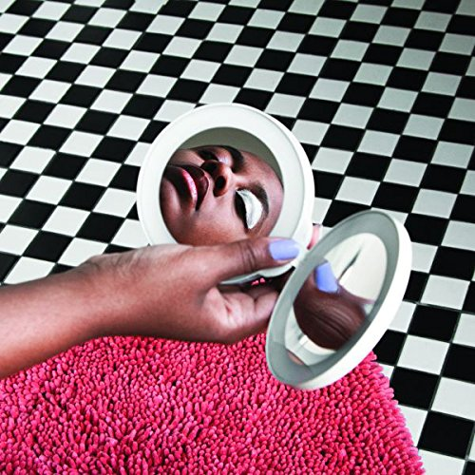
Editors’ Pick:
“The Catalyst Quartet’s Uncovered project began in 2018, growing from an idea of performing works by underrepresented composers. That blossomed into something more ambitious: a series of focused surveys, beginning with Samuel Coleridge-Taylor. ‘They have the feel of a new music project,’ said Karlos Rodriguez, the quartet’s cellist. ‘Except it isn’t new, and now it’s redefining the canon.’.” New York Times - February 12, 2021
The Catalyst Quartet Release the Most Gorgeously Memorable Album of 2021
“For the most rapturously gorgeous piece of music released so far this year, cue up the Catalyst Quartet’s new recording of Samuel Coleridge-Taylor’s Humoresque. It starts as a quasi-Balkan dance. When the sun busts through the clouds and a chorus of sorts kicks in, it’s a gut punch. The quartet’s mission in recording an all Coleridge-Taylor album is to resurrect the poignant and sublimely melodic music of this fascinating composer. It’s a trip to hear the Catalyst Quartet, champions of some of the most acerbic and sometimes challenging contemporary composers, playing such unselfconsciously beautiful High Romantic music, right down to an understated, period-perfect vibrato trailing out on the longer notes and the somewhat muted sonics of the recording. And yet, this music is rich with irony and a woundedness. Just as auspiciously, this album is the first in a planned series featuring the works of other undeservedly obscure black composers including Florence Price and William Grant Still, among many others.”
New York Music Daily – February 8, 2021
“This is a delightful selection, full of freshness and youthful ideas, demonstrating a
thorough understanding of the instruments as well as compositional architecture. The quartet provides a reading that is full of feeling, but also of a musical wisdom far beyond the composer’s years. The overall feeling is Brahmsian, yet absolutely original: all played not only with accuracy and forethought, but with a synchronicity of spirit that was most satisfying to hear. The Catalyst Quartet performs with a single voice, but what a voice it is, charged with varied moods and respect for each others’ skill and insight. There are some sweet Dvorákian moments, such as a ‘Humoresque,’ reminding us that our favorite composers live on in others whom they have influenced.” Concertonet – January 20, 2021
Dreams and Daggers with Cécile McLorin Salvant, Mack Avenue Records.
2018 Grammy Award - Best Jazz Vocal Album
“Cécile McLorin Salvant has delivered a vocal jazz album for the ages.
Studio recorded originals sprinkled throughout, featuring the exquisite
playing of the Catalyst Quartet, offer an intriguing commentary on the
live material.” TheArtsDesk – October 1, 2017
“Salvant is joined at various times by the classical string ensemble, the
Catalyst Quartet, who supply a cinematic layer of orchestration to Salvant’s
already emotive style.” AllMusic.com - September 30, 2017
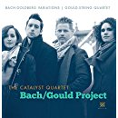
Bach / Gould Project
“The debut CD by America’s Catalyst Quartet gives us an effective and
satisfying arrangement for string quartet. It took the quartet members a
year and a half to produce their own transcription, and it’s a stunning
achievement, with a rich, warm sound right from the opening Aria and
some beautifully judged phrasing and dynamics. There is the same
exuberance and sense of sheer joy that pervades Gould’s recordings. The
decision to include Glenn Gould’s String Quartet Op.1 was a smart one.
It is a rich, complex single-movement quartet. What may be surprising is
that it is full of truly idiomatic string writing, with a great deal of contrapuntal voicing that is handled with great skill.” The Whole Note - September 2015

“It has been many years since a new arrangement of a J.S. Bach work has been so rewarding. This reviewer is entranced by the Aria which opens and closes the Goldberg Variations - music of consequence, fugal riches, and often darkly sumptuous beauty. The Goldberg Variations, as interpreted by the Catalyst Quartet, draws us to the Bach/Gould Project CD when we are ready to hear a great recording. We congratulate the members of the Catalyst on their debut release.” - AfriClassical - November 11, 2015

