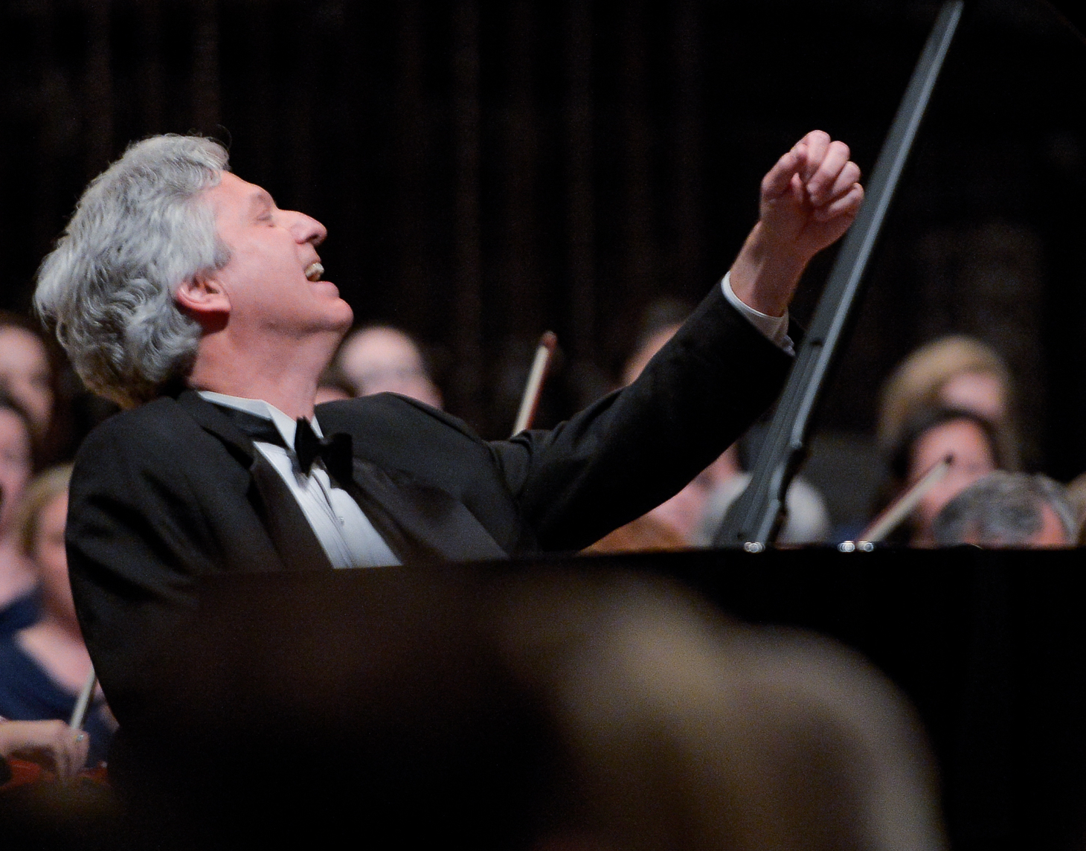

Brian Ganz

Pianist

Brian Ganz is widely regarded as one of the leading pianists of his generation.
A top prizewinner of the Marguerite Long Jacques Thibaud International Piano Competition and laureate of the Queen Elisabeth of Belgium International Piano Competition with 3rd Prize, Mr. Ganz has appeared as soloist with orchestras throughout the United States, Europe and Asia including the St. Louis Symphony, Baltimore Symphony, National Symphony Orchestra, National Philharmonic, Buffalo Philharmonic, the City of London Sinfonia, L'Orchestre Lamoureux, L'Orchestre Philharmonique de Monte Carlo, the St. Petersburg Philharmonic in Russia, and the Taipei Philharmonic Orchestra. He has performed with notable conductors such as Leonard Slatkin, Marin Alsop, Mstislav Rostropovich, Piotr Gajewski, and Yoel Levi. He has performed in some of the world’s major concert halls including the Beaux-Arts in Brussels, De Doelen in Rotterdam, L'Arena Theater in Verona, the Sibelius Academy in Helsinki and Suntory Hall in Tokyo.

The Washington Post has written: “One comes away from a recital by pianist Brian Ganz not only exhilarated by the power of the performance but also moved by his search for artistic truth.” For many years Mr. Ganz has made it his mission to join vivid music making with warmth and intimacy onstage to produce a new kind of listening experience, in which great works come to life with authentic emotional power. As La Libre Belgique stated, "We don't have the words to speak of this fabulous musician who lives music with a generous urgency and brings his public into a state of intense joy."

In January of 2011 Mr. Ganz began a monumental, multi-year project in partnership with the National Philharmonic to perform the complete works of Frédéric Chopin at the Music Center at Strathmore; concerts that have been widely hailed and performed before regularly sold out audiences. His February 2024 recital marks the 13th concert of the series. Other recent concert highlights include Chopin's Piano Concerto No. 2 at the Alba Music Festival in Italy and with the National Philharmonic at Strathmore, Mozart's Piano Concerto K. 466 with the Annapolis Symphony and Beethoven's "Emperor" Concerto with the Billings Symphony. In September 2019 he made his theatrical debut at the Smithsonian’s Freer and Sackler Galleries in Whistler, Debussy and the Lecture that Changed Art, an imagined dialogue between artist James Whistler and a musician, played by Ganz. The theater piece explored connections between Debussy’s music and the artist’s 10 O’Clock Lecture, and included excerpts from the lecture, dialogue written by Ganz and live performances of works by Debussy and others. More recently Mr. Ganz performed Mozart’s Piano Concerto K. 488 with the Virginia Chamber Orchestra at the new Capital One Hall in Virginia and appeared on the Distinguished Artists Series of Santa Cruz, California.

Mr. Ganz made his recording debut on the Gailly label in Belgium. His recordings of Chopin and Dutilleux have been released on the Accord label in Paris. In 2001 he began a project to record the complete works of Frederic Chopin for Maestoso Records. Mr. Ganz is artist-in-residence at St. Mary's College of Maryland, and for 21 years was on the faculty at the Peabody Conservatory. He is the Artist-Editor of the Schirmer Performance Edition of Chopin’s Preludes.

Updated January 2024– please discard any previous versions

Press Comments:

Ganz’s playing is arresting and sensitive.
“The word "legendary" can be used loosely, but as Brian Ganz demonstrates in a tribute concert to his long-time teacher and world-famous pianist Leon Fleisher, in this case not only is the description deserving but can be applied in many different spheres. In this online concert, Ganz plays pieces he said were inspired either directly or indirectly by Fleisher. Ganz's playing is arresting and sensitive, and especially electric in the works by Chopin. Ganz, who has received a silver medal in the Queen Elisabeth Competition in Brussels among other awards, plays regularly in the Baltimore/D.C. area despite a busy national and international concert schedule. Part of the tribute is a half-hour-long Pre-Concert Talk, which focuses heavily on the warm memories he and pianist and fellow Peabody Conservatory faculty member Marian Hahn share of the man they repeatedly call their ‘beloved teacher’. Chances are you will find yourself a little teary-eyed for the loss of Fleisher - pianist, conductor, and teacher extraordinaire." Broadway World – September 29, 2020
Ganz Concert a Breathtaking Delivery of Chopin’s Works for Pianoforte
“Pianist Brian Ganz ‘tickled the ivories’ to perfection during a recent performance of Chopin’s works for pianoforte, while also achieving a landmark in his professional career - reaching the halfway point in his quest to perform all of the composer’s 250 works for piano. If you haven’t seen Ganz in concert performing the splendid works of Chopin, you’re missing a true treat. As for his recent pairing with Wór, the evening was a delightful experience that showcased their indisputable talent. The concert was, in a word, ‘glorious.’.”
Washington Informer – February 11, 2019
“Ganz is a marvelously talented musician who exudes pure joy while he plays. His love for the music spills onto the piano and across to concert hall, filling each member of the audience. Chopin did not like writing for large spaces and Ganz captured that in the intimacy of his performance. Ganz played each piece masterfully and with such care and delicacy that the audience could not help but love watching him play.” MDTheatreGuide - February 20, 2017
“It’s been a busy year for Brian Ganz at Strathmore. This weekend Ganz visits to usher in the new season with a spirited performance of one of Beethoven’s most beloved piano concertos. Opening with the simple, solo notes of a piano, Ganz and the orchestra enter a breathtaking back-and-forth between keys and strings. The conversation that follows is delightful and revitalizing. Ganz and Gajewski make a perfect pair. Separately they are such passionate performers, together they are infectious – filling the space with their energy and pure love for music. The entire performance was beautiful, energetic, and incredibly inspiring – a fantastic way to kick-off the season.”
DC Metro Theater Arts – September 18, 2016
Beethoven’s Choral Fantasy with the Cathedral Choral Society in Washington, DC:
“Ganz opened the Fantasy with a brilliant display of improvisatory wizardry, eventually engaging the powerful chorus in a tempestuous series of variations on the familiar ‘Ode to Joy; melody.” Washington Post - May 16, 2016

“In playing some path-breaking works by Beethoven and Debussy for a capacity audience Brian Ganz chose an approach that was commanding yet thoughtful and totally musical. Ganz’s dazzling and informed playing captured the essence of each piece while making every selection his own. And his brief comments about the music were meaningful and devoid of showmanship. The pianist’s fingers, even his whole body language, propelled the listener into the music’s distant reaches of wildly emotive harmonies. The audience loved the performance and won a Chopin encore.” Washington Post - September 15, 2014
“Ganz has the impeccable hands of a competitive pianist, taking daring tempi in the outer movements of the Beethoven ‘Pathétique’ and with absolute clarity down to the tiniest note. Ganz told a story with the score, caressing unusual harmonies and melodic turns, and a crisp, even merciless finale. In the other Beethoven sonata, Ganz made his mark. The sublime concluding variations, perhaps the composer's greatest achievement in this form, elicited from Ganz a riot of ideas, each one standing on its own and yet part of a continuous narrative. Ganz took a risk with the Debussy, with which he took his time, exploring meticulously subtle ranges of color and dynamics. Three of the most familiar preludes sparked Ganz's gift for story-telling, and L'Isle Joyeuse made for an exuberant conclusion." Ionarts – September 15, 2014

Pianist Brian Ganz plays Chopin with joy, nuance and insight
“It’s easy to see why so many Washingtonians flocked to hear pianist Brian Ganz present an all-Chopin recital. Not only did the Maryland native play some joyful, nuanced pieces, he added personal commentary and musical demonstrations that were equally informative, insightful and entertaining. The pianist’s cheerful demeanor seeped into Five Mazurkas, Op. 7, where he played up the humorous moments, eliciting appreciative chuckles from the audience. In his hands, the rarely performed Trois Ecossaises, Op. 72, No. 3, became effervescent light beams. Ganz devoted his second half to the 24 Preludes, Op. 28. Each one unfolded like a course on a chef’s tasting menu - two dozen melt-in-your-mouth morsels of complementary flavors, textures and emotion.” Washington Post - January 20, 2013
“Prokofiev had a lyrical side that doesn’t often get the hearing it deserves, and this program delivered both the splash and the song in abundance. The evening’s star: pianist Brian Ganz, whose light touch in the quiet moments of the 3rd Piano Concerto was as powerful as the speed and balance he mustered as he raced through the finale.”
Washington Post - November 11, 2012

“As soloist in Piano Concerto No. 1 in C major by Beethoven, the American Brian Ganz, who appeared for the fourth time with the NSO, again pleased the audience with the interpretive sensitivity and technical skill of his performance at the keyboard. Clear articulation, nuanced timbres and alert rhythm adorned Ganz's rendition of Beethoven's first concerto. The refined reading of Brian Ganz, with the diligent and thoughtful accompaniment of Diadiura and the National Symphony Orchestra, received prolonged and warm applause from the large audience.” La Nacion (Costa Rica) - August 27, 2011

“Ganz's remarks were as heartfelt as his playing in the first installment of his projected 15-concert traversal of the master's complete works. Ganz is probably the D.C. area's most celebrated resident concert pianist. He appears frequently at Strathmore, which was packed to the rafters on Saturday, and received several standing ovations. His strong identification with this repertoire yielded performances of warmth, affection and security. At 50, Ganz is a seasoned artist, though still a boyish one. He brings a young man's delight to his work, which can be energizing. Ganz's technique is well tuned to Chopin's athletic demands. This was masterly Chopin playing overall, often deeply beautiful. He offered a particularly impressive Scherzo No. 2; it was his best outing of the evening, with splendid virtuosity in the middle section and perfectly judged rubato throughout.” Washington Post, January 24, 2011

“Brian Ganz played the solo part with gentle warmth and minimal pedal. What enthralled the capacity crowd was the muscular Ganz-de Cou rendition of Beethoven's Piano Concerto No. 5, “The Emperor”. Middle-period Beethoven, it sounded wonderful with 3 dozen musicians instead of 90. From the start to the puckish transition to an impressively speedy finale, there was easy rapport between pianist and conductor, resulting in a wholly winning performance and a tremendously upbeat start to de Cou's leadership of the VCO.”
Washington Post, September 2009

"Brian Ganz charged into the tricky piano part of Shostakovich's No. 1 Piano Concerto with remarkable élan, making the music seem thoroughly spontaneous and inevitable. He gave a bravura performance!" Baltimore Sun, February 2007

Chien-Tai Chen's concerto "Far Horizon,” Taipei Philharmonic, Kennedy Center
"Pianist Brian Ganz gave a vivid reading, from the introspective opening -- with its short, questioning statements from the piano over floating waves of orchestral color -- to its jazzy, lyrical, ballad-like middle section and the jaunty and wildly percussive close." Washington Post, July 2006

“At the end of the first half of the National Philharmonic’s program, Brian Ganz sprang up from the piano bench to hug music director Piotr Gajewski in a celebratory embrace -- and for good reason. They had just concluded an agile rendition of Rachmaninoff’s Second Piano Concerto, which sounded so luminous and pristine that it was almost as though they had plucked the notes straight from the composer’s manuscript, still wet with ink. Their performance represented a true cohabitation of music. From the start, tempos slowed and accelerated harmoniously, melodies blossomed with little exertion, and phrases accreted and subsided in a timeless manner. Ganz enthralled, not only through his flawless and effortless technique, but also his poetic pianism. Even when he glided surreptitiously across the keyboard, making the Steinway’s softest textures audible without forcing through the orchestra’s full-bodied volumes, the sounds were striking in both clarity and tonal warmth.” Washington Post, September 2006

