“ An incredible success!”
WUHAN PHILHARMONIC ORCHESTRA, China

"The finest active Brass Ensemble in all of Mexico."
FRED MILLS
Former member of the Canadian Brass

“M5´s infectious enthusiasm for performing and impeccable playing should be heard around the world.” JENS LINDEMANN
Internationally renowned trumpet soloist, formerly member of the Canadian Brass

"M5 is the best thing to come out of Mexico since tequila!
MARTIN HACKLEMAN
Principal Horn National Symphony Orchestra, Canadian Brass, Empire Brass

“In my opinion, one of the best ensembles around today!"
JAVIER ALVAREZ
GRAMMY nominated composer

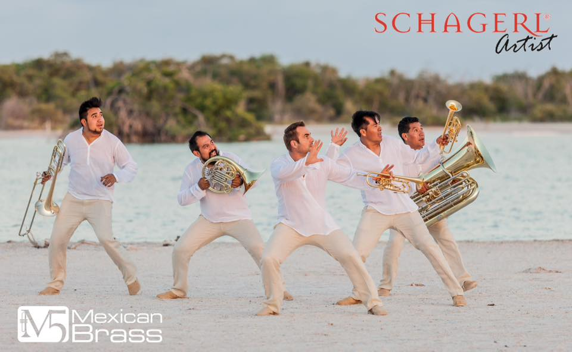
Since it’s founding in 2005, M5 MEXICAN BRASS have established themselves as Mexico's leading Brass Quintet with international recognition. Combining their skills at virtuosic chamber music in all styles, non-stop interaction with the audience, inborn showmanship, inimitable Latin American charm, and their very own sound, M5 concerts are unique musical- theatrical concert experiences.
Being one of Mexico ́s most active cultural ambassadors, the group has been touring the US and Canada extensively since 2008. M5 made its South America debut in 2012 in Colombia, performed in Algeria, Africa in 2013, China in 2014 and Chile in 2015. M5 MEXICAN BRASS has performed in renowned venues as the Kennedy Center in Washington DC and the Nezahualcoyotl concert hall in Mexico City. M5 shared the stage with worldwide-celebrated musicians like Fred Mills and Jens Lindemann. A large percentage of M5’s activities are dedicated to education, whether school concerts, workshops or master classes. In the 2014/15 season, the quintet performed educational concerts for more than 30000 children in Mexico, the US and Canada. An increasing number of contemporary composers write new works for M5.

RESUME

* U.S. Tours
2015: 3 month Washington, Oregon, Arizona, California, Florida, Wyoming, D.C., Pensylvania
2013: concerts in Washington, California, Arizona and Illinois
2011-2012 season: 2, 8-week tours throughout 14 states performing 81 concerts;
2010-2011 season: New Mexico-tour, concerts in Los Angeles, San Francisco,
2009-2010 season: concerts in California, Chicago and Florida
2008-2009 season: concerts in Texas, Colorado, Nebraska, Vermont and Pennsylvania

* Canadian Tours
2013: performances / recording in Canada: Montreal and Vancouver
2008/2011 Participants by invitation at the Banff Summer Music Festival and the Brass Residency Program at The Banff Center, Alberta, Canada

* Mexican Tours
Michoacán (2014),
State of México, Mexico City, Guanajuato, Jalisco, Zacatecas (2013),
Festival Cultural de Sinaloa (2012), State of Tamaulipas (2011),
Veracruz and Aguascalientes (2010), Ten-State tour (2007).

* Guest artists at international music festivals:
Teatro Municipal de Las Condes, Santiago de Chile (2015)
Wuhan Hubei, China with Wuhan Philharmonic Orchestra (2014)
Merida International Brass Festival (2014/15)
Festival Culturel International de la Musique Symphonique Algers, Algeria (2013)
International Music Festival of Cartagena, Colombia (2012);
Banff Summer Arts Festival, Canada (2011/2008);
International Music Festival of Morelia (2005/09/14);
Festival de Tamaulipas (2011);
Chamber Music Festival Aguascalientes (2010),
FAOT Sonora (2010); Festival QUIMERA (2009/14),
Meadowlark Music Festival Nebraska (2008);
Stowe Music Festival, Vermont (2008);
JAZZTIVAL Morelia (2008) etc.
INSTRUMENTA TRADICION in Oaxaca (2007)

* CD recordings: “That’s A Plenty” (2006), “Bach” (2010). “M5 on Tour” (2013)
* Scholarship recipient of the Mexican National Arts Council FONCA (2013, 2007)
* Resident ensemble of the CONSERVATORIO LAS ROSAS, Morelia, Michoacán
* Organizers of the BRASSFEST MORELIA 2007 with special guest FRED MILLS (former Canadian Brass)
M5 MEXICAN BRASS– THE PLAYERS
Alexander Freund - Trumpet
Born in Germany, Alex studied with Bob Platt, Konradin Groth (Berlin Philharmonic) and Peter Leiner (“Das Rennquintett”) at the Universities of Arts in Berlin and Saarbrücken. He has participated in courses with Rainer Auerbach (Berlin State Opera), Jens Lindeman, Allan Vizutti, Tim Morrison, Hannes Läubin, James Thompson etc. Alex has been invited to play with well-known orchestras as the Berlin State Opera, Semper Opera Dresden, Cologne Radio Orchestra, Tenerife Symphony Orchestra etc.. In Germany he had contracts with the Opera and Philharmonic Orchestra of Bremen, Deutsches Theater Berlin, Disney's production of “The Hunchback of Notre Dame” etc., in México he was principal trumpet of the Michoacán Symphony Orchestra and the symphony orchestras of Monterrey and Mineria in Mexico City. He performed as a soloist in Mexico, Korea, Italy, Germany and France. Alex lives with his family in San Miguel de Allende, is currently trumpet professor at the Conservatorio de las Rosas in Morelia, and teaches Ishaya Meditation.

Oscar Villegas MIRANDA - Trumpet
Originally from Santa Catarina del Monte, Oscar studied at the National Conservatory of Music in Mexico City under maestro Francisco Peralta (National Symphony Orchestra of Mexico, and has participated in master courses with Philip Smith (New York Philharmonic), Pierre Dutot (Paris Conservatory), Boyd Hood (Los Angeles Philharmonic) and Uwe Köller (German Brass), among others. He has performed with The State of Mexico Symphony, the Symphony Orchestra of Xalapa, and the Guanajuato Symphony Orchestra, and was Co-Principal with the Michoacán Symphony Orchestra. Currently Oscar plays Principal Trumpet and soloist with the Philharmonic Orchestra of Toluca. Oscar and Alex are the founding members of M5 MEXICAN BRASS. He lives with his wife and two little girls in his birthtown in the mountains of Texcoco.

JUAN CARLOS QUITERIO MIGUEL – French Horn
Born in Mexico City, Juan Carlos began playing music at age seven, and soon joined the José Pablo Moncayo Youth Orchestra. He studied french horn at the National School of Music (UNAM) with Elizabeth Rising Kinsey. Juan Carlos has participated in master classes with such well-known musicians as Guelfo Nalli, Radovan Vladcovic, Martin Hackleman, and Jon Gustely, as well as with members of the German Brass and Canadian Brass. Juan Carlos played principal horn in the Youth Symphony Orchestra in Toluca, the Michoacán Symphony Orchestra and the Symphony Orchestra of the State of Hidalgo in Pachuca. With the members of M5, he has participated in classes with Fred Mills and Jens Lindemann, Jim Thompson and Andrew Hitz. Juan Carlos is currently principal horn player in the Philharmonic Orchestra of Toluca. He lives in Mexico City.

José Lopez Juárez – Tuba

Jose was born in Texcoco and studied at the National Conservatory of Music and at the Culture Centre “Ollin Yolitztli” in Mexico City with Erasto Vázquez and Dwight Sullinger (Mexico City Philharmonic Orchestra). José has participated master classes with Alan Trudel and with members of the Meridian Arts Ensemble and the San Luis Brass Quintet. He toured Mexico for two years with a student brass quintet and regularly plays with the symphony orchestras in Mexico City, Guadalajara, Acapulco, Xalapa, Monterrey and Guanajuato. José has been principal tuba with the Pachuca Symphony Orchestra since 2002. He lives with his wife and 3 kids in in the mountains of San Jeronimo Amanalco, Texcoco, where he conducts his own sinfonic wind orchestra.

ROBERTO CARLOS CRUZ – Trombone
Born in San Bartolo Cuautlalpan, State of México, Carlos studied at the National Conservatory of Music with Benjamín Alarcón Bear and participated in masterclasses with Jacques Mauger (Paris Opera), Dr.James Lebens (Université Laval de Quebec), Michael Mulcahy (Chicago Symphony), José Leonardo León (Florida Opera), Ángel Subero (Boston University), etc. In 2010 he was first trombone in the Philharmonic Orchestra of Toluca (OFIT) and in 2011 second trombone in the Orquesta Filarmónica de la Universidad Autónoma de México (OFUNAM). He is frequently invited to perform with mayor Mexican orchestras like the OFUNAM, Mexico City Philharmonic Orchestra, Orquesta Sinfónica de Minería, Camerata de Coahuila and Orquesta de las Américas. The METALES M5´s trombone player since 2012, he is the youngest member of the quintet.
M5 MEXICAN BRASS - PRAISE and PRESS

“M5 models their shows on the successful formula of high entertainment coupled with extraordinary virtuosity. They created their own sound and identity…their infectious enthusiasm for performing and impeccable playing should be heard around the world.” JENS LINDEMANN
Trumpet soloist, formerly member of the Canadian Brass

“M5 is the best thing to come out of Mexico since tequila! Their sense of style, showmanship, and virtuosity is a rare treat not to be missed.” MARTIN HACKLEMAN
Principal Horn, National Symphony Orchestra, former member Canadian Brass, Empire Brass

“M5 came and conquered Nebraska! I have never before seen a group so well received and with such joy as Metales M5. This superb group was an absolute Grade A hit everywhere they appeared.” BILL SMITH
Artistic Director Meadowlark Music Festival Nebraska

"This group of five very fine musicians have established themselves as the finest active Brass Ensemble in all of Mexico.” FRED MILLS
Former member of the Canadian Brass

"...It's hard to find a group of musicians with such musical bravura and refined technical ability, all bundled into one ensemble… Not only does M5 MEXICAN BRASS produce a unique sound, but manage every time to engage audiences in programs displaying a sense of adventure…in my opinion, one of the best ensembles around today!" JAVIER ALVAREZ FUENTES
GRAMMY nominated composer

“I found M5´s mix of quality music and innovative performance to be unique and engaging.”
SANDRA LARONDE
Director Aboriginal Arts, THE BANFF CENTER, Canada

“Excellent and virtuosic - M5 is a Gran Fiesta de Música!” ALEXANDR PASHKOV
Internationally acclaimed concert pianist“

We are grateful for the opportunity to have shared this amazing group with Vancouver audiences. They have been incredible at getting the kids excited about music, about teaching them how to listen to music, and about the brass instruments – all under the cloak of serious entertainment!
It doesn’t get much better than that.” SIMONE DOUST
Music in the Morning Concert Series, Vancouver, BC

“What an incredible event! We were all amazed, thank you so much for providing such a wonderful and inspirational experience to our school. JEN ROSE
Director of Production, The Sarah McLachlan School of Music, Vancouver, BC

“What a wonderful engagement! Standing ovations and lots of compliments!” MICHELE ROBERGE
Executive Director Carpenter Performing Arts Center Long Beach, CA

“M5 is a consistent hit with our cultured and discerning audiences. A delightful blend of fine music, wry humor, great staging and a winning rapport with the audience makes M5 one of the hottest brass groups I have ever heard.” KEN BICHEL
New York recording artist and composer, Board Member of ProMusica SMA

“Brilliant, charming, extraordinary, funny, joyous, magical, spectacular, unique, wacky and wonderful…” http://www.atencionsanmiguel.org/2013/12/benefit-for-school-for-deaf-kids-amuses-with-sound-and-vibration/ ATENCION SAN MIGUEL DE ALLENDE

http://www.entretantomagazine.com/2015/01/04/metales-preciosos-merida-international-brass-festival-2014/ “The iconic Jose Peon Contreras Theater presented the singular Metales M5 who did just what they do best: share their talents with the music of Bach, Humperdinck, John Williams, Astor Piazzolla and Leonard Bernstein. With M5 and Jens Lindemann sharing the stage, there was widespread evidence that magic also has a sound and could only be created and interpreted from deep knowledge of brass, these impetuous instruments, provocateurs of movement and action. A pleasant, very inspiring and enthusiastic experience.” ENTRETANTO MAGAZINE MERIDA

“Combining high quality music with fun entertainment, Metales M5 Mexican Brass, maintained the enthusiasm of their audience at the Festival Cultural Sinaloa 2012. The five extraordinary musicians filled the large hall with their magnificent interpretations and showmanship, converting the event into a fiesta of talent and joy -with closed eyes they sound like a complete philharmonic orchestra.” FESTIVAL CULTURAL SINALOA

“What do you get when you mix the shenanigans of the Blues Brothers with the musical seriousness of the Canadian Brass? Metales M5! Mexico's leading brass quintet, which opened this summer's Meadowlark Music Festival, rarely takes itself seriously. They performed with real polish and panache - these five musicians are genuine virtuosos.” JOHN PITCHER Omaha World-Herald
“…the musicians are contagious with their joy and happiness…in this concert, music was treated with all honors and dignity that it deserves. M5´s special ingredients are: changing costumes, illumination and candles for a special touch. The most interesting thing about METALES M5 is, that their spontaneity and entertaining attitude is always justified by interpretations that make us easily appreciate the high virtuosic level, musical sensitivity and outstanding ability of its members.”
HERALDO Aguascalientes

“M5 brought laughter and smiles from the audience, listening to a brass quintet with such a wide range of sounds that it sounded like a complete orchestra, magically executed by each of the five members of the group. The venue seemed to change with the varied lighting and clothing changes. M5 showed the enormous possibilities of their sound variety in a tango by Astor Piazolla, giving it its appropriate colors, passion and LA JORNADA, Aguascalientes “The quintet with clear international projection, presented a concert of unusual music from the XX and XXI century: All the pieces were originally composed for brass quintet, some of them exclusively for M5. A spectacular and extraordinary concert…the program continued with the spirit of M5´s typical audience interaction, having fun playing good music, charming, sparkling and educational. Brilliant, energetic and played with first qual CAMBIO DE MICHOACAN

Mexican brass quintet and Pueblo symphony: A joyous combination"…joyous- somewhere between inspiration, jollity and fanfare. Happily, M5 fill the bill with a modicum of charm and some raucous humor as well. There were two encores and two standing ovations, Metales M5 was a big hit here in Pueblo." Pierre Kenyon, The Pueblo Chieftain, CO

“We could not believe the magnitude and beauty of the sound….it was infinite ecstasy that the group generated, especially the brilliance of the piccolo trumpets. With wisdom and freshness Alexander Freund led us through two hours of music history. It was notable how much they enjoyed themselves and the interest they showed in communicating with the public. They told stories, delighted with excellent interpretations, danced and had so much fun…“ CAMBIO DE MICHOACAN

Tech Rider

Lighting
- 13 spots (5 behind the curtain, 3 on front stage, 5 in audience)
- Follow Spot
- White Cyclorama
- Colours: red, blue, green, amber, purple, pink (saturated on cyclorama)
- Console Stage manager
- Large or 2 small Dressing Rooms
Set up time for musicians: 2 hours
Set up time for light: 2-4 hours

Sound (In case of being an open-air concert)
- 1 microphone for voice
- 5 wireless microphones (optimal) with tweeze (Sure or Sennheiser)
or 5 ambience microphones (hanging)

Theatre/ Concert Hall:
1 microphone for voice
5 music stands (to be confirmed)

Catering
Water, juice, fruits, tea, coffee, milk
Per diem.

Hotel
5 individual rooms with breakfast.

Photographs, Video + Audio

http://www.metalesm5.com

Contact

CALIFORNIA ARTISTS MANAGEMENT
www.calartists.com

Susan Endrizzi Morris, Co-Director
sue.endrizzi@gmail.com

Phone: 707-937-4787
Cell: 415-302-1083

STAGE SET UP for LIGHT DESIGN

- White Cyclorama (aprox. 30 ft behind curtain)
- Colors: Red, Blue, Green, Amber, Pink, Purple
(Saturated colors on cyclorama only)
- Sharp edged position spots, dramatic, no general stage wash
- Follow spot
- Gobos: if available
We are happy to adapt our requirements to your stage possibilities.

SPOT-POSITIONS:

- Entrance Position (3ft behind the curtain):
5 square spots (sharp edged, from top), in a straight line parallel to curtain,
5ft between each other, separated spots (only used for the very beginning)
X X X X X
_______________________________________curtain
Front stage

- Main Positions X (front stage):
Half-circle with 5 symmetrical positions, open to the audience
(12ft from central X to stage edge, 4 ft between each player)
3 wide, sharp edged spots (first house) covering the 5 positions without shade inside (Color: warm skin tone)
X

__________ ____________
X
X
X
X
1
curtain curtain

_______ front stage M (microphone)
stage limit audience
4

ail

O
ail

2

OO

- Audience positions
spot 4 and 5 in
3 ail
Follow spot in 5th row center stage left:
3rd+10throw
Spot 2 in ail
stage right 7th row

- Microphone spot M (stage left, edge of stage, 8ft from centre)
When Microphone spot is ON, Main Position is dimmed to 60%
If there is not sufficient stage in front of the curtain, the main position X will always be
marked at 12ft distance to the stage limit.

