Arto Noras
Cello

Discography
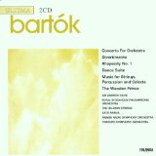
Bartok Concerto for Orchestra, Royal Stockholm Philharmonic, Sir Andrew Davis, conductor, Finlandia Records

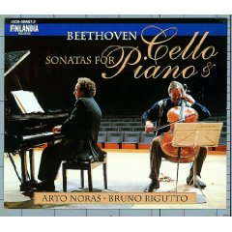

Beethoven Cello Sonatas, Bruno Rigutto, piano, Finlandia Records

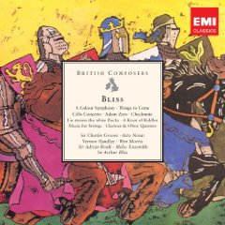

Bliss Cello Concerto, Bournemouth Symphony Orchestra, Paavo Berglund, conductor, EMI Records

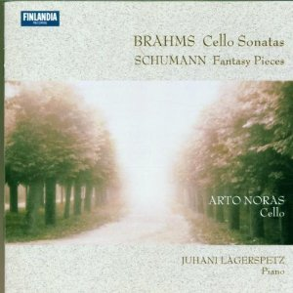
Brahms Cello Sonatas, Juhani Lagerspetz, piano,
Finlandia Records
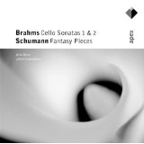
Brahms Cello Sonatas, Schumann Fantasy Pieces, Juhani Lagerspetz, piano, Finlandia Records

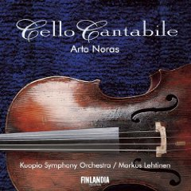
Bruch Kol Nidrei, Kuopio Symphony Orchestra, Markus Lehtinen, conductor,
Finlandia Records

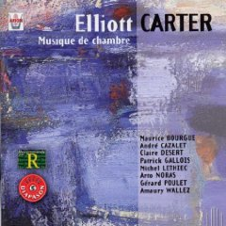
Elliott Carter, Chamber Music, Arion Records

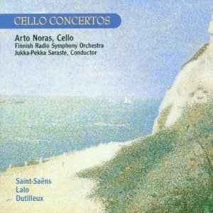
Cello Concertos, Finnish Radio Symphony Orchestra, Jukka-Pekka Saraste, conductor, Finlandia Records

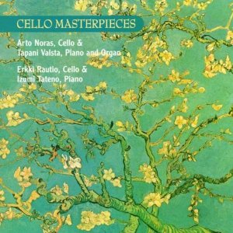
Cello Masterpieces. Tapalni Valsta, piano and organ,
Finlandia Records

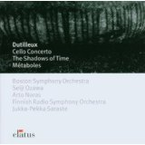
Dutilleux Cello Concerto, Finnish Radio Symphony Orchestra, Jukka-Pekka Saraste, conductor, Finlandia Records
Dutilleux, Agopov, Cello Concerto, Finnish Radio Symphony Orchestra, Jukka-Pekka Saraste, conductor, Finlandia Records
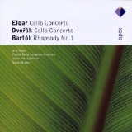
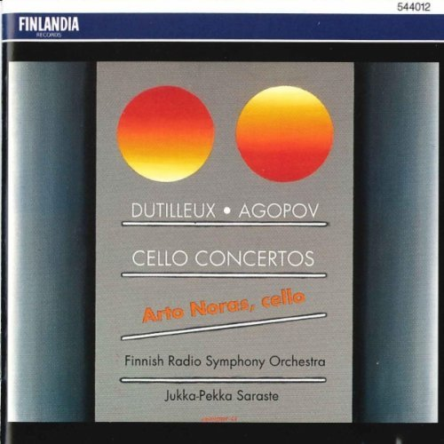
Elgar, Dvorak, cello concertos, Bartok Rhapsody, Finnish Radio Symphony Orchestra, Jukka-Pekka Saraste, conductor. Apex Records

Elgar, Dvorak, cello concertos, Bartok Rhapsody, Finnish radio Symphony Orchestra, Jukka-Pekka Saraste, conductor. Fazer Records, Finlandia

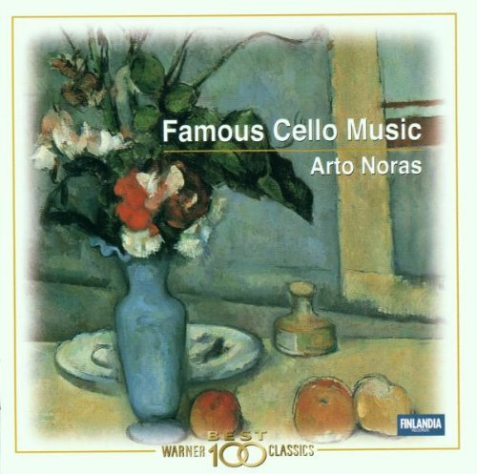
Famous Cello Music, Finlandia Records

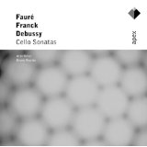
Faure, Frank, Debussy Cello Sonatas, Bruno Rigutto, piano
Apex Records.

Haydn Cello Concertos, Slovak Chamber Orchestra, Bohsan Warchal, conductor,
X5 Music Group

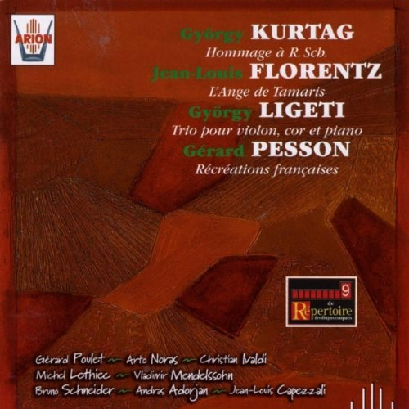
Kurtag Homage a R. Sch., etc. Christian Ivaldi, piano, Arion Records

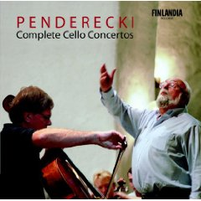
Penderecki Complete Cello Concertos, Finlandia Records

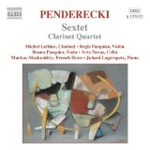
Penderecki Divertimento for solo cello, Juhani Lagerspetz, piano, Finlandia Records

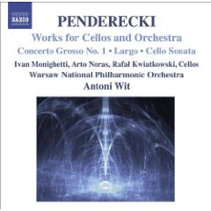
Penderecki Concerto Grosso No. 1, Warsaw National Philharmonic, Anton Wit, conductor, Naxos Records

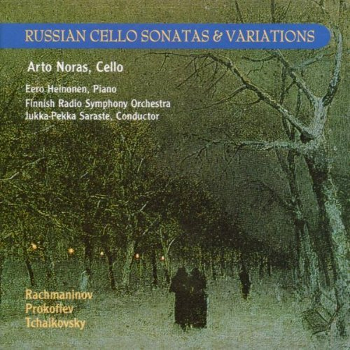
Russian Cello Sonatas and Variations, Finnish Radio Symphony Orchestra, Jukka-Pekka Saraste, conductor, Finlanfis Records

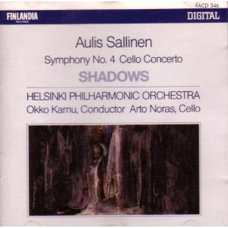
Aulis Sallinen: Cello Concerto, Helsinki Philharmonic, Okko Kamu, conductor,
Finlandia Records

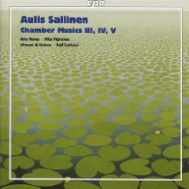

Aulis Sallinen, Chamber Music, CPO Records

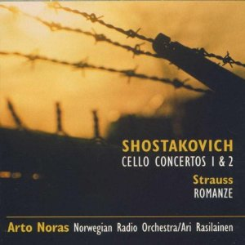
Shostakovich Cello Concertos, Norwegian Radio Orchestra,
Finlandia Records

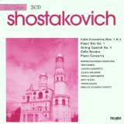

Shostakovich Cello Concertos, Norwegian Radio Orchestra,
Finlandia Records
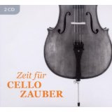
Zeit für Cello Zauber, various artists, composers
Warner Classics

